Pediatric Asthma
Name
Institution of Affiliation
Professor
Date

Pediatric Asthma
Emergency Room Scenario
Kimberly is a six-year-old child who was brought to the emergency department by her mother due to the acute onset of respiratory symptoms. The mother reports that the baby is a known asthmatic who has been on follow up due to the condition. She takes some drugs that help in maintaining her free from an asthmatic attack. The child today developed sudden onset shortness of breath, productive cough, wheezes. The mother reports that the patient can complete sentences. The mother reports that the symptoms were triggered by exposure to cold when the child was playing outside with her friends. She also developed chest tightness which made normal breathing difficult and that is why she was brought to the hospital. The mother reports that she had tried to use an inhaler to relieve the symptoms without success and that is why she brought the patient to the hospital. There is a positive history of running nose and sputum production. No history of hotness of the body. The eating patterns have not changed.
Pathophysiology of Asthma
The patient who is a known asthmatic has some form of allergy to environmental factors which together with genetic factors facilitates the patient's condition. When the patient is exposed to the allergen, the immune system exaggerates the response and this leads to inflammation of the airway tissues (Szefler et al., 2019). The hyper-response causes the bronchi and bronchioles to produce mucosal edema due to hyperemia and attacking by the immune system cells such as monocytes, immunoglobulins like IgG and IgE. Neutrophils also play a role in the inflammatory process in the mucosal walls of the respiratory system (Tesse et al., 2018). Besides, histamines and related cells respond by increased production and this also causes symptoms of obstruction in asthma. All these processes lead to excessive bronchospasms, mucus production causing mucus plugs and mucosal edema. Also, there is vasoconstriction caused by the hypoxic alveoli. The result is airway obstruction which in turn leads to airflow resistance and a decrease in expiratory of the inspired air (Becker & Abrams, 2017). This leads to hyperinflation of the lungs hence seems of chest tightness and wheezing. The excessive mucus production leads to mucus plugs in the air hence irritation and productive cough.
Pharmacological Principle of Asthma
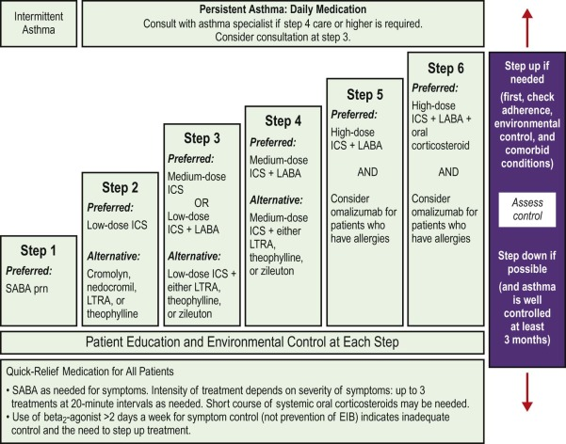
One Related Medication and Its Properties
Management of asthmatic attacks follows a stepwise protocol until and the main goal is to relieve the symptoms and prevent exacerbations. One of the widely used medication is salbutamol. It is a selective beta 2 agonist and acts on the beta 2 receptors by stimulating and activating them leading to an increase of the intracellular concentration of cyclic-3′, 5′-adenosine monophosphate hence activation of protein kinase A with end results of relaxing the smooth muscles of the respiratory system causing its patency (Katzung, 2017). It is considered a short-acting beta 2 agonist and is used mainly as a symptoms reliever. It is used in nebulization and also as an inhaler like in the MDI (metered-dose inhaler). The drug is indicated in asthma relieve and maintenance of symptoms free state. In addition, it is used in chronic obstructive pulmonary disease (COPD), exercise-induced bronchospasms and chronic bronchitis. It is metabolized in the lungs and the liver and later eliminated via the kidneys through urine. According to Katzung (2017), adverse reactions for the drug include hypokalemia, hypertension or hypotension, hyperglycemia, palpitations, dizziness, headache, and muscle tremor. Albuterol decreases the elimination rate of abacavir.

References
Becker, A. B., & Abrams, E. M. (2017). Asthma guidelines: the Global Initiative for Asthma in relation to national guidelines. Current opinion in allergy and clinical immunology, 17(2), 99-103.
Katzung, B. G. (2017). Basic and clinical pharmacology. McGraw-Hill Education.
Szefler, S., Vogelberg, C., Jugovic, B., de la Hoz, A., & Hamelmann, E. (2019). Commentary: Treating Pediatric Asthma According Guidelines. Frontiers in Pediatrics, 7, 109.
Tesse, R., Borrelli, G., Mongelli, G., Mastrorilli, V., & Cardinale, F. (2018). Treating pediatric asthma according guidelines. Frontiers in pediatrics, 6.

